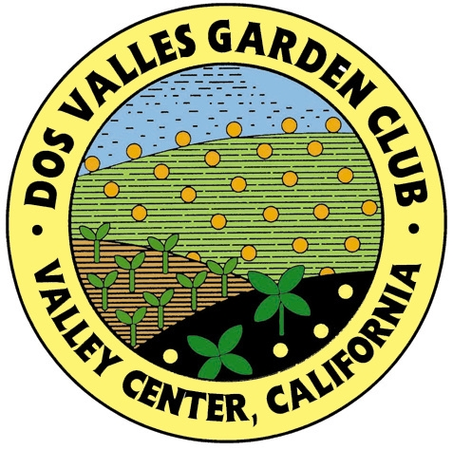
DOS VALLES GARDEN CLUB
Membership Renewal 2023-2024

Single Membership $40
Family Membership $50
Supportive Membership $100

Make your check payable to DOS VALLES GARDEN CLUB

Please complete the form if there are changes from last year’s yearbook:
Note: highlight or underline any information which would change your
roster listing.

NAME _____________________________________________________Birthday____________________

SPOUSE ___________________________________________________ Birthday____________________

MAILING ADDRESS _____________________________________________________________

STREET ADDRESS _______________________________________________________________

E-MAIL _______________________________________

TELEPHONE _ ____________________Cell___________________________________________

Indicate if any of the following applies to you:

__ Charter Member __ Master Gardener
__ Gardening Consultant __ National Life Member
__ Pacific Region Life Member __ Master Flower Show Judge
__ Master Flower Show Judge Emeritus __ Past DVGC President

Please return this completed form with your check before JULY 1, 2023.

Give or send to:
Connie Lee
PO Box 1142
Pauma Valley, Ca 92061
Questions? Call Connie, 760-742-3905
Cell 760-300-6932

